Thomas F. DeFrantz; dancing among the watery folds. liquid blackness 1 April 2021; 5 (1): 107–117. doi: https://doi.org/10.1215/26923874-8932625
Reprinted with permission from the author for use in slomoco seminar.

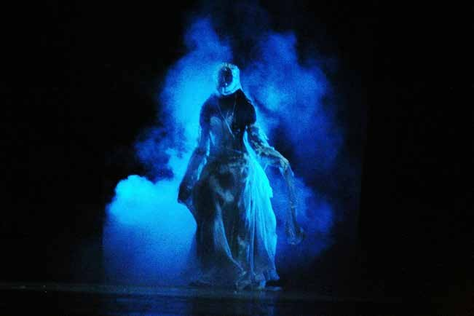

FIGURE 1. Makeda Thomas in “FreshWater” (2009). At 7 Arts Centre in Harare, Zimbabwe, for Harare International Festival of Arts. Photo by Agueda Sanfiz. Courtesy of the artist.

■■
dancing among the watery folds

THOMAS F. DEFRANTZ

Liquid blackness might be a shifty sort of vigi- lance; a reckoning with waterways as transit, refuge, birthcanal, tearducts. How do we dance among the folds of history that seem to evacuate Black presence? Yemonja, Oshun, Olokun, Steal Away. We moisten, shine briefly, and disperse, leaving our sweat.
L
Is this wake work? Tears of joy honoring the shifting time that recurs.
An exploration of dance and the aesthetic imperatives of embodied communication.
And surely we dance among the watery folds?
■■

To dance would be to engage a creative embodied reckoning with and among. [among] Each other, yes, even as we recognize continuity from one to the next; that ancestors are already here and part of the planning forward for black possibilities. We are always already in motion [of course], and to animate that motion with expressive intention would be to dance. So this is a dance in the spaces of in- betweenness, where blackness might be manifest as its own answer to a question of survival and encouragement, expansion and kinship. Beyond the space of disavowal, or the coerced “dancing” on the slave ships—which was thought to be separated from creative potential, even if we know better—we move intentionally toward an un-knowing, an extralinguistic un-choreographic that will not be bound by words or instructions. Intentionality within blackness as the valuing of a moving toward; a dancing that engages the technologies of memory/motion/desire/ amongnesses.

A liquidity of blackness might be bound up with possibilities that flow over, under, and around; some- times through. But in motion, always, in motion.

sweat.
PS5 controllers will likely analyze biofeedback information, including heart rate and sweat. The idea will be to give players a more immersive experience, with more nuanced responsiveness for video games. To propel players to play up, toward their potential and excitement. To incite a desire to work harder, but not so hard that they stop playing the game. Hand sweat and heart rate to track how the experience progresses, where its boundaries lie, what metrics change through time at play.
Sweat indicates excitement and fear. A response of the body to shifting circumstances; a response to motion. Dancing, we sweat.
Sweaty Black people have long been deployed as signs of primality, as the masses of unwashed, subhuman labor. As lustful bucks or jezebels; as overworking ciphers of unthinking productivity-as- physical-effort. For the uninitiated, the sweat needs to be cleaned off to reveal human subjectivity.
Water coming out from the body; an alchemy that engages the largest organ, skin. Amazingly, the cool that characterizes black performance seldom excludes sweat from its conditions. Sweat might pour from the body, and still the performance conveys a cool, casual disinterest. Rather than revving up toward a limit, black performance sweats cool, sweats willingly, toward transformation.

Sweating through focus, and working a willingness toward the exchange. We smile in the CouCou, not blankly or stupidly, as in without intention, but to demonstrate our ability to ride the rhythm and imagine more than the labor of the dance, more than the sweat that will come. The sweat consecrates the body, the body encompassed by skin, bathing us with information made of physical motion, transformation. The water from within confirms change as an eternal possibility; reminds us to care for an intensity of performance that produces sweat.
Sweat as the baptism of effort, the physical manifestation of divine possibility. A becoming of process made fleshly.

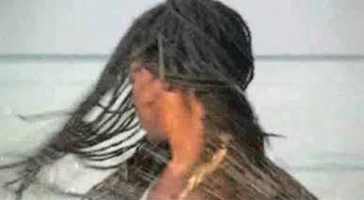
FIGURE 2. Makeda Thomas in “Costa del Alma” (2008). Artistic direction and performance, Makeda Thomas; cinematography, Panu Kari; lighting, Camal Gaiby. Featuring “Om Mani Padme Hung,” by Yungchen Lhamo. Courtesy of the artist.

DEFRANTZ ■■ dancing among the watery folds 109

FIGURE 3. Makeda Thomas in “Costa del Alma” (2008). Artistic direction and performance, Makeda Thomas; cinematography, Panu Kari; lighting, Camal Gaiby. Featuring “Om Mani Padme Hung,” by Yungchen Lhamo. Courtesy of the artist.

LIQUID BLACKNESS MIGHT BE A SHIFTY SORT OF
VIGILANCE; A RECKONING WITH WATERWAYS
AS TRANSIT, REFUGE,
BIRTHCANAL, TEARDUCTS

drink.
In spirit service, we drink rum to create the space for the mystères. The invisibles come and demand that we drink: white rum, flaming rum, spitting rum out, but swallowing it, ingesting it. Drink.
The loas dance, and we drink rum to accompany the motion. To allow motion to fulfill itself, to move our “sense of self” out of the way. To allow toward transcendence, and, again, the fleshly process. Black religions dance, moving through prescribed gestures that are techniques of dancing, but always toward the spontaneous, something else dancing that can’t be predicted. The embodied “speaking in tongues.” Jerking, lurching, sinuous movement that surprises some of us who witness, sure that those gestures would not usually be possible.
[I went to an aesthetics conference in New Orleans among researchers I didn’t know. An older gentleman asked me pointedly to speak to voodoo. I thought, of course African based religion systems are danced faiths; we value the body and its processes in every form of creative address. What I felt, though, was his too-white desire to have a Black researcher “out” our spiritual practices as alterity to Western aesthetics. As if. As if the Blood of Christ were antithetical to the li- bations of rum. But one drinking might be an end to participation in the sacrament, while the other is an opening out toward danced faith.]

110 liquid blackness ■■ 5:1 ■■ April 2021

Liquid going into the body expands its contents and speeds its alterations. We drink to know our bodies differently. We dance to unlearn the everyday habits of coercive containments, of respectable black mo- tion. Imbued with fluid, otherly-moves emerge, danc- ing toward deliverance.

moisten.
To anticipate liquidity is to moisten: the lips, the eyes, the skin. Cocoa butter and Visine. To prepare toward an encounter, to enliven before the fact.
Anticipatory pleasure is a privileged possibility. To render the self toward readiness of my own volition, hopefully, on my own time. A prelude that I might arrange for us, a moistening before a deluge. We used to enjoy the rush of preparation before going out to the club; the anticipation of an encounter full of mysterious unknowability. Maybe an evening of lovemaking; K-Y and Astroglide to prepare the orifices. All that was before quarantines of COVID-19. Now we moisten hesitantly or not at all, sequestered in apartments in Brooklyn, NY, or in the housing complex of Charlotte, NC. Encounters might still come, with those we already know and trust, at least a little bit. We might forget how to prepare, how to ready toward an unexpectedness. Except that we already know how to prepare fear; fear of another impossible hospitalization that won’t end well, or to prepare for a shift at work without the proper safety equipment—the ubiquitous PPE. Black life ridden with precarity, no reliable sources of PPE available. COVID-19 arrives as another version of something we already know: a hostile environment and an invisible assailant incapacitating us indiscriminately. We know that preparation is always toward a world of disavowals and hurts; unrealizable potentials.
Preparations often for naught.

HOW DO WE DANCE
AMONG THE FOLDS OF HISTORY THAT SEEM
TO EVACUATE BLACK PRESENCE?

Except that the moistening is its own activity, and realizes itself as an event of preparation, even as if [for naught]. And the event is realized now differently, in solo practices: dancing in the quarantine bedroom. Strutting and spinning in the small space alongside the sleeping pallet, avoiding the light fixture, bumping into the wall giddy to see the room differently, in some sort of blur. Moistening the imagination toward a futurefreedom, a dancing tomorrow practiced for now, maybe for TikTok or Insta, but in imagination towards. In preparation. We become even better at preparing for the inevitable breaking of the levees. We mourn, and celebrate, in anticipation of . . .

DEFRANTZ ■■ dancing among the watery folds 111

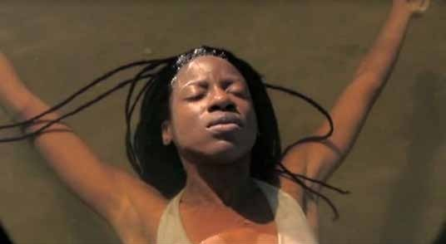

FIGURE 4. Makeda Thomas in “Costa del Alma” (2008). Artistic direction and Performance, Makeda Thomas; cinematography Panu Kari; lighting, Camal Gaiby. Featuring “Om Mani Padme Hung,” by Yungchen Lhamo. Courtesy of the artist.

melt.

Changing state becomes the queer affordance of dancing in blackness. From this to that, briefly; not this nor that as the approach to dancing. Riding rhythm to change our embodied capacity and move beyond whatever might be presented by sound; changing state in a series of minor revisions, small articulations and revisions, reexperiencing.
Queering this stance, to move like that. Queer as a process thrives in mixed-messages. Not as an identity here, but as a delta of dance. A melting.
QueerBlack, or afroqueer, moves through like water, claiming presence as quickly as it dissipates into dance. Intentional, embodied creative gesture: dance. Always realized queerly, as we never quite achieve the doing that we imagine.

Every movement becomes something else because it has to; we have no method to comprehend or assess how our moving is. We can only reflect through what we imagine moving could be; what we wanted it to be. In practice, though, our gestures are small failures and tiny triumphs; queer elaborations of desire and intellect colliding. Melting through intuition.
Melting might be a rearticulation of fugitive practices; shifty vigilances. To be available and nimble, we dissemble. Surviving, we practice a willingness to recalibrate continually; to melt and reform, dissipating as process. Creating intentionally, we dance toward a more-ness, moving into gesture and deepening the impulse in relation to the beat.
We open toward and through queer in this dissemblance, in this melting, because how could we not, and isn’t it entirely valuable to be able to?

112 liquid blackness ■■ 5:1 ■■ April 2021

To remake the self, which is already moving, in an unexpected difference from just then, in the melting change of now and now and now and NOW? Time queers effort in dancing. We slip time in revising through the beat. Time that was never straight, or solid. Black time, queer time, queer gesture, dance gesture.
And these days we embody queer in an impossible sociality of physical distancing: we go outside and stay apart. A queer trick, and yet another one that we know well: apart-playing. Play your part; bring yourself into the formation. Hold the group, and change yourself in response. Melt. We remake ourselves in the ensemble, queerly passing through variance, one, to the next, to the group, to the whole.

cry.
What we don’t need to see, and probably never did want to witness, was our own despair. Our tears.
The watering that is often against the will. A needed watering, yes, but not needing to be recovered by the group again and again.
Images of black despair form endless streams of photojournalism. Rafts of images confirming coerced black capitulation to white supremacy. Black tears, reproduced again and again. Trauma crafted to evoke. After all, the stories of wailing with wet eyes stand as incitement to an entire line of afropessimist theory. In an abolitionist action, we mobilize the tears to compel a shift, a rethinking, a reordering.

RATHER THAN REVVING UP TOWARD A LIMIT,
BLACK PERFORMANCE
SWEATS COOL, SWEATS WILLINGLY, TOWARD
TRANSFORMATION

DEFRANTZ ■■ dancing among the watery folds 113

We cry, of course we cry. Usually, though, we are #rosaparksSTRONG. Pushed back to strength, proclaiming thisbridgecalledmyback. Outraged and ireful, strong and irrefutable. #notimefor[black]tears. Dancing, we cry tears of deliverance. Of arriving more than this world, this time, this place. We cry as we dance toward allah and god, toward Ochún and her watery ways. To move with Oshun allow the let-go through the technique, to arrive in flow with what can never be [fully comprehended]. We can know of Olóòkun but we can’t know them, we can only move toward and through, alongside, in availability. We can cry in our innocence in this; that we don’t understand how we met or what we bring to each other, but we can weep in our assembly, and because we animate the deities. Malcolm X cried when he realized that he somehow knew how to dance.
Liquid blackness hides its tears. Holds them back. Redacts them. An entire trail of Black people moved, against our will, from North to South where a profit could be generated: a nineteenth-century #TrailofBlackTears. Of course there was crying always, but what’s the point? “I’ll give you something to cry about.”

Cry, Alvin Ailey’s quintessential collaboration with dancer Judith Jamison, dedicated “to all Black women everywhere, especially our mothers,” ends in triumph, with the dancer tearing at the earth and sky simultaneously, delivered.
AND THESE DAYS WE EMBODY QUEER IN AN IMPOSSIBLE SOCIALITY OF PHYSICAL DISTANCING: WE GO OUTSIDE
AND STAY APART. A QUEER TRICK, AND YET ANOTHER ONE
THAT WE KNOW WELL: APART-PLAYING.

float.
Our bodies are mostly water, the scientists say, but we were already summoned to water as an inevitable, pleasurable component of Blackliving. Revel in the water; bathe, release, consume, baptize/worship.
Discover embodied queer capacities within watery folds. Cry to be replenished through emotion and rhythm toward an unmaking of this world and the imagining of another.

Sometimes we float. To preserve, seeking refuge. To triage. Or to avoid. Some of us intend to stay out of the fray. Moving away, to regard at a distance, we float/they float, staying above it all. They float, generating models that don’t necessarily intend to embrace the liquid movements of black creativity.

114 liquid blackness ■■ 5:1 ■■ April 2021

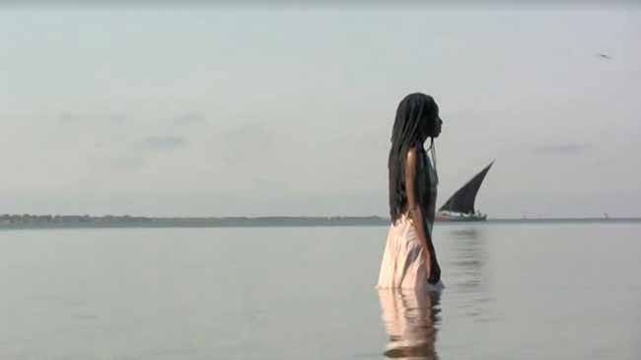
FIGURE 5. Makeda Thomas in “Costa del Alma” (2008). Artistic direction and performance, Makeda Thomas; cinematography, Panu Kari; lighting, Camal Gaiby. Featuring “Om Mani Padme Hung,” by Yungchen Lhamo. Courtesy of the artist.

They float away, theorizing in order to colonize contents and affects. Translating gesture toward a disengaged semi-assembly, the floaters discern blackness as a massing of fascinating excess; as an exemplar of alterity that reveals whiteness to whites. Floating, they forget to dance among, or they dance badly, because they dance apart from black possibilities that demand rhythm as central to the watery transformations. Rhythm means to be hard to wrangle, it operates as the pivotkey for Blacklife. We can confess that we are not good dancers, and still get on the floor|move toward the water.

we. must. dance.

DEFRANTZ ■■ dancing among the watery folds 115

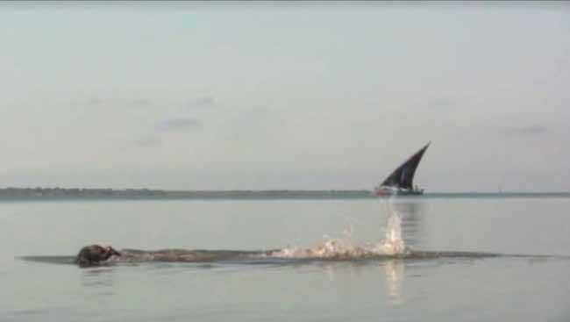
FIGURE 6. Makeda Thomas in “Costa del Alma” (2008). Artistic direction and performance, Makeda Thomas; cinematography, Panu Kari; lighting, Camal Gaiby. Featuring “Om Mani Padme Hung,” by Yungchen Lhamo. Courtesy of the artist.

swim.
Because we must be among each other in a future-past-present doing toward our commons. An intentional embodied creativity [dance] that elaborates queer time toward an ensemble of practice. Becoming Black by relating, in process, to the beat. Breaking the beat, of course, like the brace of cold water on a hot brow. Moving through it.
Swimming, we engage wake work as intentional creative effort to move with the water, its ebbs and flows. Resist it, for a time, but find its essence in its motions. Our liquid motions, slippery and profound, minor gestures all in dance, calling forth the birthing pool where Blacklife continues, wily and wet.
■■

116 liquid blackness ■■ 5:1 ■■ April 2021

THOMAS F. DEFRANTZ directs SLIPPAGE:Performance| Culture|Technology, a group that explores emerging tech- nology in live performance applications. Believes in our shared capacity to do better and engage creative spirit for a collective good that is antiracist, antihomophobic, pro- tofeminist, and queer affirming. Professor at Duke Univer- sity and specializes in African diaspora aesthetics, dance historiography, and intersections of dance and technology. Publications include the Routledge Companion to African American Theater and Performance (with Kathy Perkins, Sandra Richards, and Renee Alexander Craft, 2018), Cho- reography and Corporeality: Relay in Motion (with Philipa Rothfield, 2016), Black Performance Theory: An Anthology of Critical Readings (with Anita Gonzalez, 2014), Dancing Many Drums: Excavations in African American Dance (2002), and Dancing Revelations: Alvin Ailey’s Embodiment of Afri- can American Culture (2004). Among recent creative works there are fastDANCEpast, created for the Detroit Institute for the Arts; and reVERSE-gesture-reVIEW, commissioned by the Nasher Museum in response to the work of Kara Walker.

References
Ball, Edward. “Retracing Slavery’s Trail of Tears.” Smithsonian Magazine, November 2015. www.smithsonianmag.com
/history/slavery-trail-of-tears-180956968/.
Crawley, Ashon T. Black Pentecostal Breath: The Aesthetics of Possibility. New York: Fordham University Press, 2016.
Daniel, Yvonne. Dancing Wisdom: Embodied Knowledge in Hai- tian Vodoun, Cuban Yoruba, and Bahian Candomblé. Cham- paign: University of Illinois Press, 2005.
Ferguson, Roderick A. Aberrations in Black: Toward a Queer of Color Critique. Minneapolis: University of Minnesota Press, 2004.
Griffin, Andrew. “Ps5 Controller Could Track ‘Biofeedback’ Such as Sweat and Heart Rate, Patent Suggests.” Independent, Feb- ruary 26, 2020. www.independent.co.uk/life-style/gadgets
-and-tech/news/ps5-controller-playstation-new-biofeedback
-heart-rate-sweat-patent-a9360231.html.
Harney, Stefano, and Fred Moten. The Undercommons: Fugitive Planning and Black Study. Wivenhoe: Minor Compositions, 2013.
Hartman, Saidiya. Lose Your Mother: A Journey along the Atlantic Slave Route. New York: Farrar, Straus and Giroux, 2008.
Hazzard-Gordon, Katrina. Jookin’: The Rise of Social Dance For- mations in African-American Culture. Philadelphia: Temple Uni- versity Press, 1990.
Moten, Fred. Black and Blur. Durham, NC: Duke University Press, 2017.
Sharpe, Christina. In the Wake: On Blackness and Being. Durham, NC: Duke University Press, 2015.
Thompson, Robert Farris. Aesthetic of the Cool: Afro-Atlantic Art and Music. Pittsburgh: Periscope, 2011.
Welsh, Cariama, Esailama G. A. Diouf, and Yvonne Daniel. Hot Feet and Social Change: African Dance and Diaspora Commu- nities. Champaign: University of Illinois Press, 2019.

DEFRANTZ ■■ dancing among the watery folds 117

